BÍ KÍP THẦN LONG ĐẠI HIỆP VỀ HỆ ĐIỀU HÀNH

Link bài giảng Y (tham khảo): <https://www.youtube.com/watch?v=dOiA2nNJpc0&pp=ygUQb3BlcmF0aW5nIHN5c3RlbQ%3D%3D>

Link bài tập:

<https://uteduvn-my.sharepoint.com/:f:/g/personal/22h1120005_ut_edu_vn/EhvvyaQa2JJEkDZ1W9GFWYwBjPuaPSFV2DR9G0zWinVtfQ>

1. Consider the following page reference string: 1,2,3,4,2,1,5,6,2,1,2,3,7,,6,3,2,1,2,3,6 How many page faults would occur for the following replacement algorithms, assuming four frames?Remember all frames are initially empty, so your first unique pages will all cost one fault each. Use Optimal(OPT) Replacement Select one:

A. 8

B. 12

C. 14

D. 10

1. Apply Dynamic Storage-Allocation is best-fit, what is the remaining memory? Given five memory partitions of 150 KB, 600 KB, 300 KB, 200 KB, and 500 KB (in order), place processes of 222 KB, 415 KB, 112 KB, and 456 KB (in order)? Select one:

a. 150,388,200,300,388

b. All are wrong

c. 38,144,78,200,85

d. 150,144,78,88,85

1. 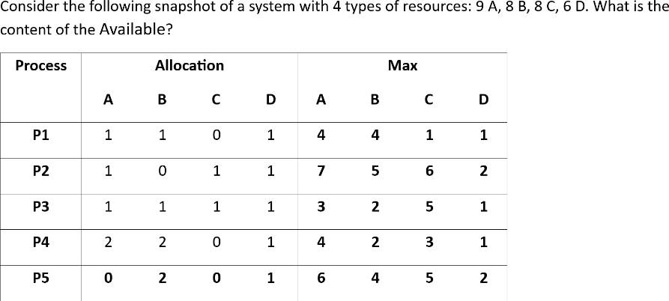

Select one:

1. A B C D

3 2 6 1

1. A B C D

4 1 6 1

1. A B C D

4 2 5 1

1. A B C D

4 2 6 1

1. 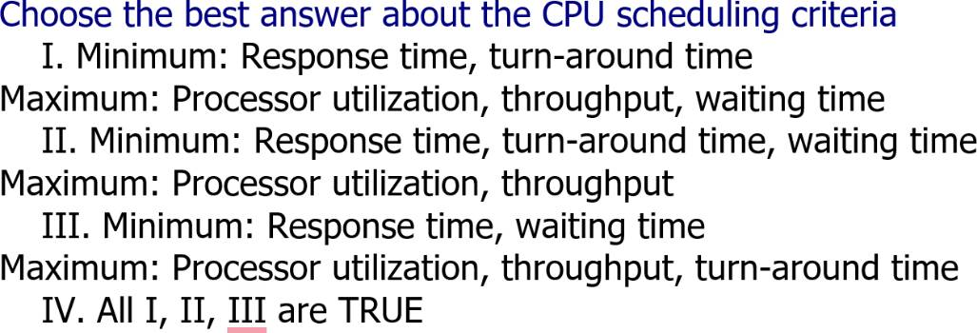

Select one:

a. II

b. I

c. IV

d. III

1. The term "Operating System" primarily serves as:
2. An intermediary between computer hardware and users.
3. A component that runs applications.
4. A set of programs managing hardware resources.
5. All of the above.

Select one:

a. I

b. II

c. III

d. IV

1. Choose the correct statement(s) about Polling Controller sets ___, executes transfer. Select one:

a. busy bitwait bit

b. error bit

c. wait bit

d. command-ready

1. choose the correct answer regarding the advantages of using loadable kernels modules? Select one:

a. Limited flexibility in adding new functionalities

b. Improved system performance

c. Difficulty in updating kernel features

d. Increased kernel size

1. choose the correct answer regarding the purpose of the system call? Select one: a. To interact with computer hardware

b. To provide a user interface

c. To execute user programs

d. To request services from the operating system.

1. a process is said to be in the ... state if it was waiting for an event that will never occur. Select one:

a. Ready

b. Deadlock

c. Blocked

d. Terminate

1. Select answer: Semaphore is a/an _______ to solve the critical section problem. Select one:

a. integer variable

b. All are TRUE

c. None of these

d. special program for a system

1. There are ... way(s) of handling deadlocks, which are
2. 4, deadlock prevention, deadlock avoidance, deadlock detection, and recovery, ignore the problem altogether.
3. 3, deadlock prevention, deadlock detection, and recovery ignore the problem altogether
4. 2, deadlock prevention, deadlock detection and recovery
5. All are TRUE

Select one:

a. IV

b. I

c. II

d. III

1. which of following is not correct regarding fcfs? Select one:

a. It may lead to the "convoy effect" where shorter processes are stuck behind longer ones.

b. FCFS scheduling algorithm is preemptive.

c. It is a non-preemptive scheduling algorithm.

d. It follows the principle of first come, first served.

1. Choose all that are true about the deadlock avoidance method: I. A state is safe if the system can allocate all resources requested by all processes (up to their stated maximums) without entering a deadlock state. II. All safe states are deadlock-free, but not all unsafe states lead to deadlocks. III. This method does not need the system to have some additional a priori information available. Select one:

a. II, III

b. I, II, III

c. I, II

d. I, III

1. Choose the state that is not a process state Select one:

a. Running

b. Blocked

c. All are TRUE

d. Terminated

1. Consider a logical address space of 8 pages of 1024 words each, mapped onto a physical memory of 64 frames. How many bits are there in the logical address? Select one:

a. 11

b. 13

c. 14

d. 12

1. Consider a logical address space of 8 pages of 1024 words each, mapped onto a physical memory of 64 frames. How many bits are there in the physical address? elect one:

a. 15

b. 16

c. 14

d. 13

1. In the threading model, the entire process will block if a thread makes a blocking system call.
2. One-to-One
3. Many-to-Many
4. Many-to-One

Select one:

a. II

b. III

c. I, II

d. I

Các câu hỏi còn lại đều nằm trong phần bài tập ở đầu trang. Chúc bạn thi tốt~

